**NAME**

**JAHNZAIB ZAFAR**

**SECTION**

**BS ARTFICIAL INTELLIGENCE– 3B**

**TASK (4)**

**PART NUMBER 1**

**TOPIC**

**CHECK CARD NUMBER,LUHN**

**OUTPUT**

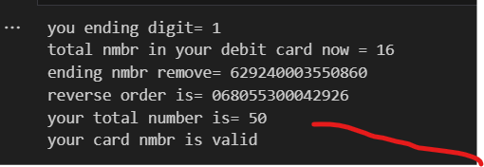

**EXPLANATION**

* I HAVE MAKE THE CODE FOR **CHECKING ANY DEBIT CARD NUMBER** .
* IN WHICH FIRSTLY **REMOVE SPACES** AND THEN END DIGIT GIVE TO VARIABLE AND REMOVE FRIM THESE NUMBERS.
* **REVERSE THE ORDER** ,THEN **MULTIPLY TWO** IF INDEX NUMBER IS EVEN AND **MINUS NINE** IF ANSWER OF MULTIPLY GREATER THEN NINE.

IS TOTAL OF NUMBERS AND THEN **ADD NUMBER** WHICH WAS ASSIGN TO VARIABLE  
NOW DIVIDED BY 10 IF **MOD WILL 0 THEN OUE CARD IS VALID** OTHER WISE NOT VALID .  
  
**TOPIC**

**REMOVE PUNCTUATIONS   
OUTPUT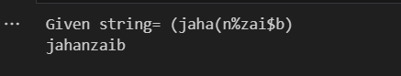 EXPALANTION  
 I have make the code in which if any special character come into our sentences ,they will be remove   
only set is_digit if digit then come other charaters will be remove  
TOPIC**

**SENTENCE and word CORRECTION  
OUTPUT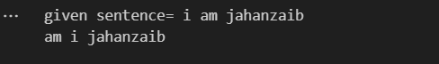 EXPALANATION**

* make code for bubble sort where I **check date the alphabet** or sentence is sorted according to askii code .  
    
  in which charcter wise solved like we have take variable string   
    
  in which we add the string   
  two loops are used ,for iteration and comparison.
* in which use **split method** for separate the strings.
* **First loop** is used for **itration** .
* **Second loop** is **for compare** in which n-1-I so that after each iteration one **comparison** will be lost and other start.
* Have arranges **three variable** and replaces their places .
* Now **,join use** for arranging the word in sequence.